**Project Name**

### CRM Application for Jewel Management - (Admin)

**By**

NAME**: VAMSI PALYAM**

Email**: vamsipalyam7330@gmail.com**

**Abstract**

The CRM application for jewel management is meant to streamline interactions with clients in the jewelry sector and make those processes more effective. The admin module enables the management of all stocks, customer information, and sales monitoring from one place. Admin panel users can edit the product list, observe the orders, and even control the personnel performance. The application incorporates real-time analytics plus report generation for deep wisdom. This functionality includes user authentication, role-based access control, and data security, which serve to protect sensitive customer information as well as financial data. CRM colors customer interaction, makes communication automatic, and is a means of conducting marketing campaigns thus guaranteeing customer treatment that is not alike for anyone.

**KeyWords**:  
CRM, jewel management, admin module, inventory, customer data, sales tracking, product catalog, real-time analytics, report generation, user authentication, role-based access control, data security, customer engagement, marketing campaigns.

**INDEX Page**

|  |  |  |
| --- | --- | --- |
| Topics |  | Page no |
|  |  |  |
| 1. SALESFORCE |  | 04 |
| 2. OBJECT |  | 05 |
| 3. TABS |  | 07 |
| 4. THE LIGHTING APP |  | 08 |
| 5. FIELDS |  | 09 |
| 6. PROFILES |  | 25 |
| 7. ROLES |  | 26 |
| 8. USERS |  | 28 |
| 9. PAGE LAYOUTS |  | 29 |
| 10. RECORD TYPES |  | 31 |
| 11. PERMISION SETS |  | 33 |
| 12. USER ADOPTION |  | 35 |
| 13. REPORTS |  | 37 |
| 14. DASHBOARDS |  | 38 |
| 15. FLOWS |  | 40 |

**INTRODUCTION**

Are you new to Salesforce? Not sure exactly what it is, or how to use it? Don’t know where you should start on your learning journey? If you’ve answered yes to any of these questions, then you’re in the right place. This module is for you.

Welcome to Salesforce! Salesforce is game-changing technology, with a host of productivity-boosting features, that will help you sell smarter and faster. As you work toward your badge for this module, we’ll take you through these features and answer the question, “What is Salesforce, anyway?”.

What Is Salesforce?

Salesforce is your customer success platform, designed to help you sell, service, market, analyze, and connect with your customers.

Salesforce has everything you need to run your business from anywhere. Using standard products and features, you can manage relationships with prospects and customers, collaborate and engage with employees and partners, and store your data securely in the cloud.

**TASK 1: CREATING ADEVELOPER ACCOUNT**

Creating a developer org in salesforce.

1. Go to <https://developer.salesforce.com/signup>
2. On the sign up form, enter the following details :

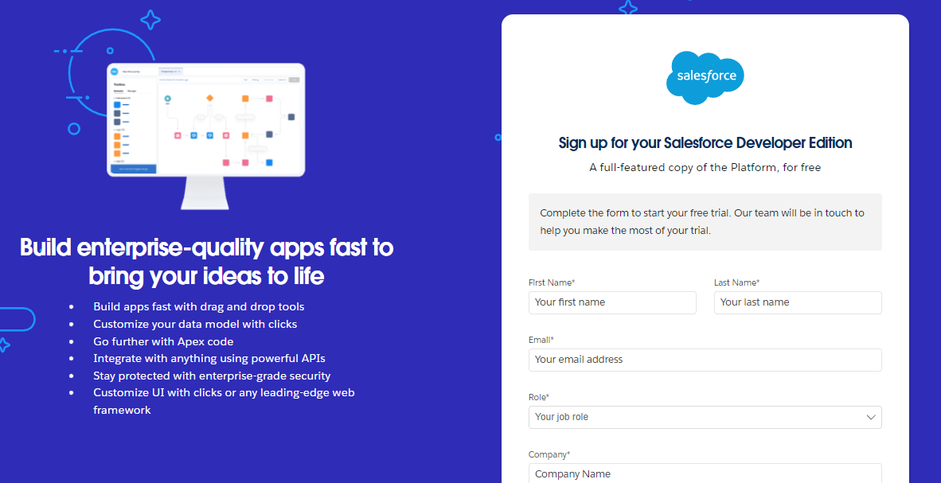

1. First name & Last name
2. Email
3. Role : Developer
4. Company : College Name
5. County : India
6. Postal Code : pin code
7. Username : should be a combination of your name and company

This need not be an actual email id, you can give anything in the format: username@organization.com

Click on sign me up after filling these.

### TASK: 1.1 :Account Activation

### Go to the inbox of the email that you used while signing up. Click on the verify account to activate your account. The email may take 5-10mins.

### https://lh7-us.googleusercontent.com/f9p6lLf1S6xj-4TVHFr3TXpsdg9mqywBGPavcd-32E9svZbySYTT36QXVPDwsq1YtjC8RZsB2-q2CQbIiI8cmx1Eefgwohm2-CtcdQa8aYArLe5cIVAoTTIeHft05yWsf1tSr3dmBH3OTe9tVJ-KHw

Click on Verify Account

Give a password and answer a security question and click on change password.

Then you will redirect to your salesforce setup page.

### TASK:2 Object

### 2.1 Create Jewel Customer Object

The purpose of creating a Jewel Customer custom object is to store and manage information about Customer.

To create an object:

From the setup page  >> Click on Object Manager  >> Click on Create  >> Click on Custom Object.

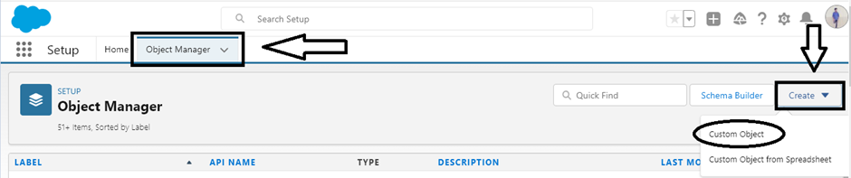

Enter the label name >> Jewel Customer

Plural label name >> Jewel Customers

Enter Record Name Label and Format

* Record Name  -->  Customer name
* Data Type  -->  Text

Click on Allow reports.

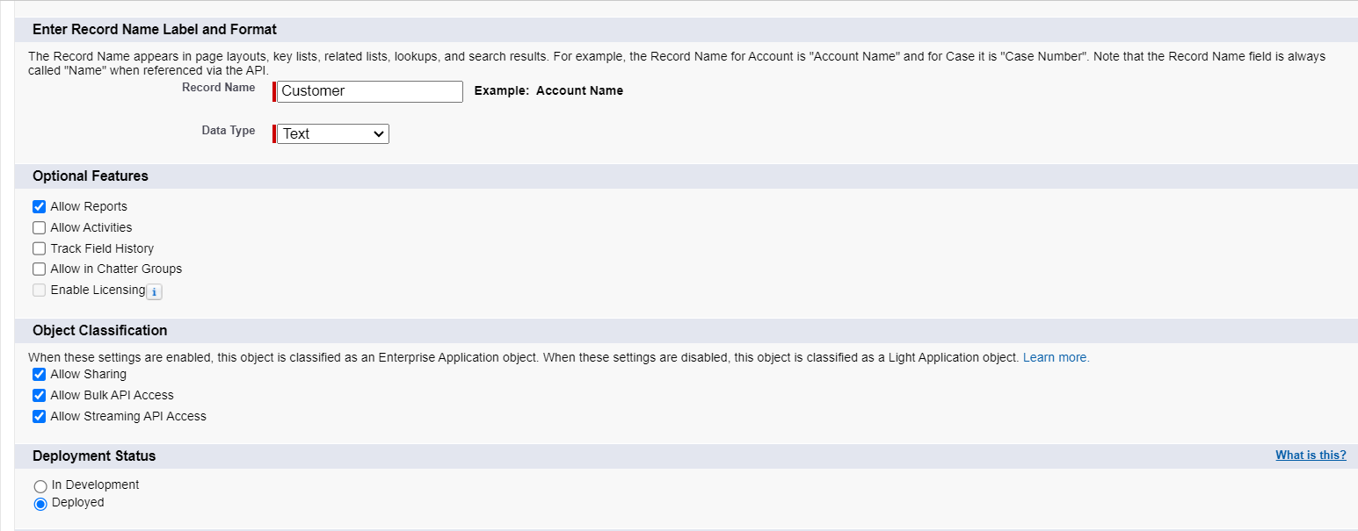

Allow search  --> Save.

**2.2 Create item object**

The purpose of creating a Item object is to manage the inventory of gold and silver items.

To create an object:

1. From the setup page   >> Click on Object Manager  >>  Click on Create  >>  Click on Custom Object.
2. Enter the label name >> Item
3. Plural label name >>  Items
4. Enter Record Name Label and Format

* Record Name  >>  Item Id
* Data Type >> Auto Number
* Display Format >> Item-{00}
* Starting Number >> 1

1. Click on Allow reports.
2. Allow search >> Save.

Note: Create 3 more objects with label names as Customer Order,Price,Billing

### TASK:3 TABS

### 3.1 Creating a Custom Tab

To create a Tab:(Customer)

1. Go to setup page >> type Tabs in Quick Find bar >> click on tabs >> New (under custom object tab)   
   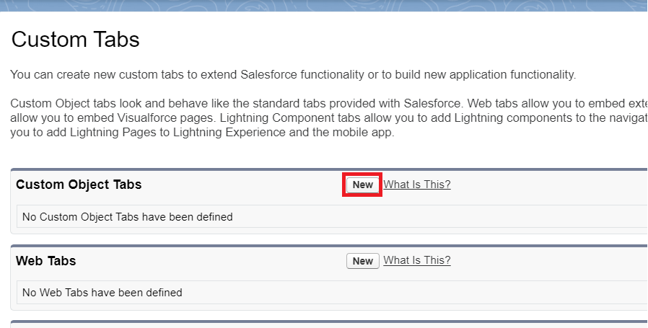
2. Select Object(Jewel Customer) >> Select any tab style >> Next (Add to profiles page) keep it as default >> Next (Add to Custom App) keep it as default >>Save.

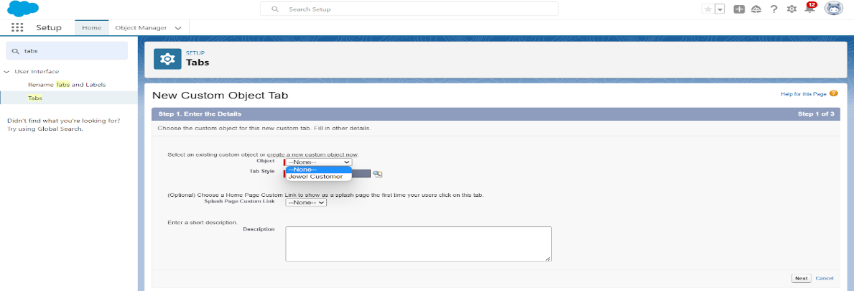

### 3.2 To create a Tab:(Item)

1. Go to setup page >> type Tabs in Quick Find bar >> click on tabs >> New (under custom object tab)
2. Select Object(Item) >> Select the tab style >> Next (Add to profiles page) keep it as default >> Next (Add to Custom App) keep it as default >> Save.

Note:Now create tabs for Customer Order, Price, Billing objects.

### TASK:4 The Lightning App

### 4.1Create a Lightning App

To create a lightning app page:

1. Go to setup page>>search “app manager” in quick find>>select “app manager”>>click on New lightning App.

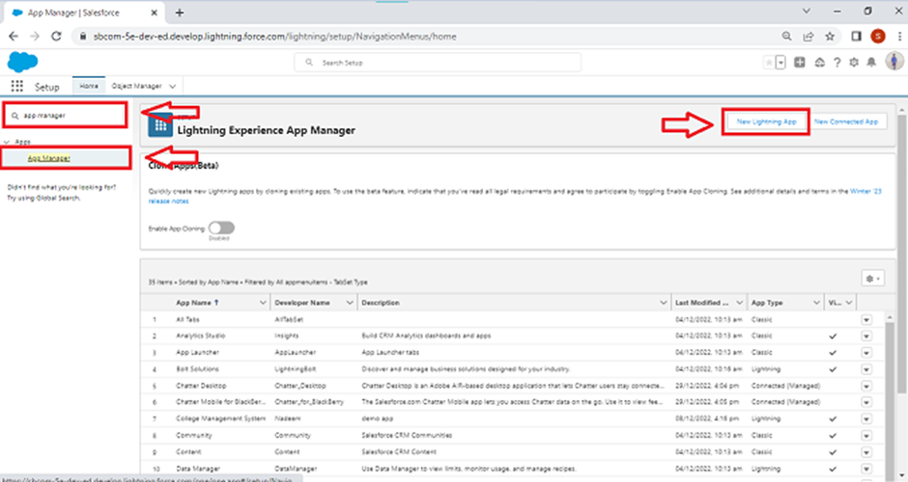

1. Fill the app name in app details and branding as follow  
   App Name: Jewellery Inventory System.  
   Developer Name: This will auto populated  
   Description: Elevate your look with elegance  
   Image: optional (if you want to give any image you can otherwise not mandatory)  
   Primary colour hex value : keep this default.
2. Then click Next >>(App option page)Set Navigation Style as Console Navigation>>Next.
3. (Utility Items) keep it as default>>Next.
4. To Add Navigation Items:
5. To Add User Profiles: 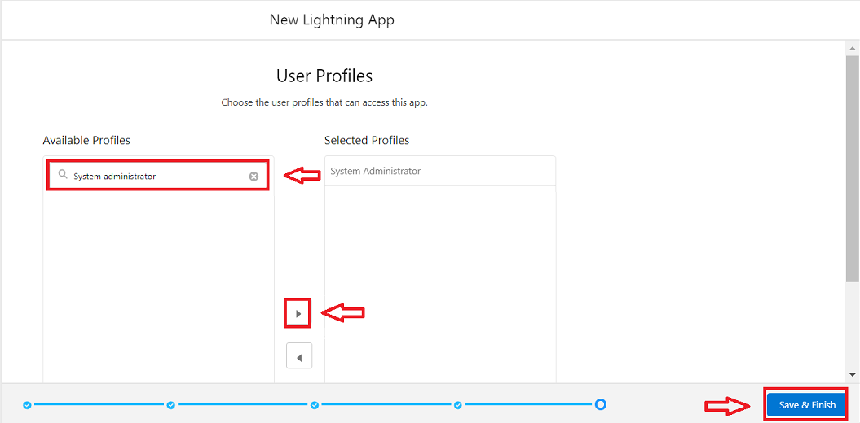

Search profiles (System administrator) in the search bar>>click on the arrow button>>save & finish.

### TASK:5 Fields

### 5.1 Creating Lookup Relationship

### To Create a relationship between Jewel Customer & Customer Order Objects.

1. Go to the setup page >> click on object manager >> type object name(Customer Order) in the quick find bar >> click on the object.
2. Click on fields & relationship >> click on New.
3. Select “Lookup relationship” as data type and click Next.
4. Select the related object “ Jewel Customer ”.
5. Give Field Label as “Customer” and click Next.
6. Next >> Next >> Save.

### 5.2 Creating a Master-Detail Relationship

Creating Master-Detail Relationship between Item & Customer Order Object.

To Create a Master-Detail relationship :

1. Go to the setup page >> click on object manager >>  type object name(Customer Order) in the quick find bar >> click on the object.

2. Click on fields & relationships >> click on New.

3. Select “Master-Detail relationship” as data type and click Next.

4. Select the related object “ Item ”.

5. Give Field Label as “Item” and click Next.

6. Next >> Next >> Save.

### 5.3 Creating Text Field in Jewel Customer Object

To create fields in an object:

1. Go to setup >>click on Object Manager>> type object name(Jewel Customer) in quick find bar >> click on the object.  
   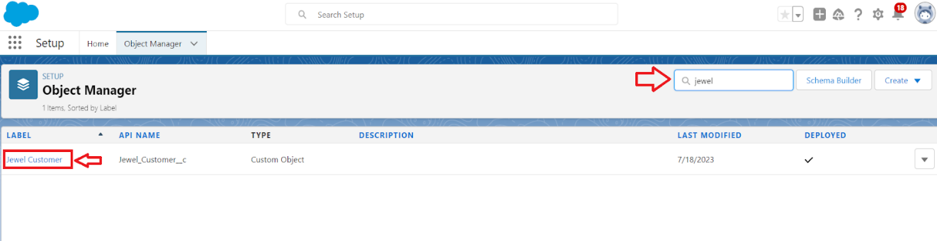
2. Now click on Fields&Relationships” Select Data type as “Text”.? New 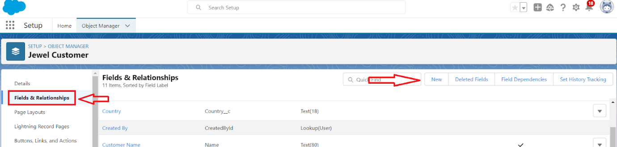
3. Select Data type as “Text”.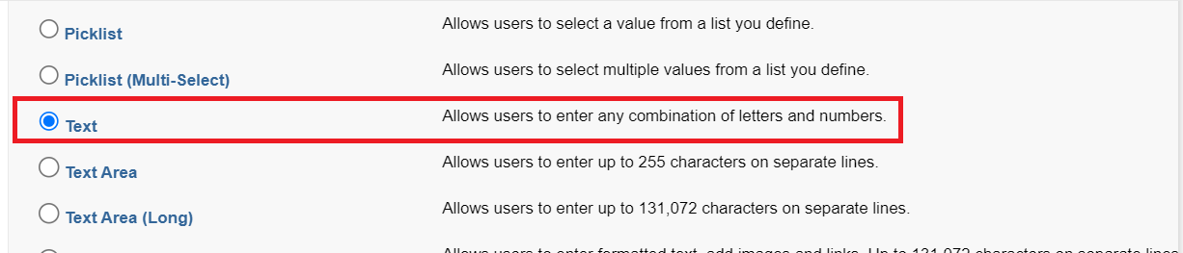
4. Click on Next.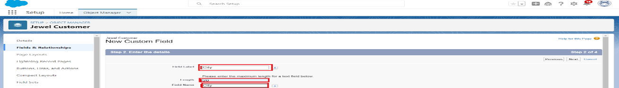

Fill the above as following:

* Field Label: City
* Length : 20
* Field Name : gets auto generated
* Click on Next >> Next >> Save and new

### 5.4 Creating the Phone field in object Jewel Customer

To create fields in an object:

1. Go to setup >> click on Object Manager >> type object name(Jewel Customer) in quick find bar >> click on the object.
2. Now click on “Fields & Relationships” >> New
3. Select Data type as “Phone” and click Next.
4. Given the Field Label as “ Phone”.

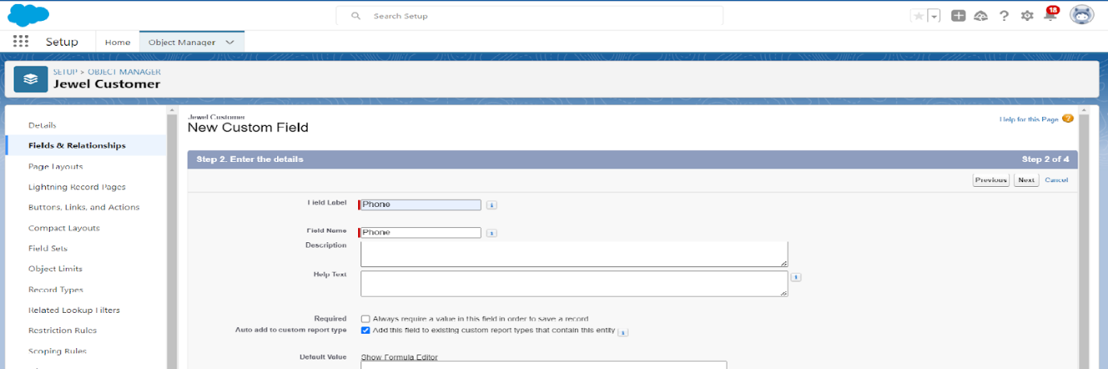

1. Field Name will be auto populated, and click on Next >> Next >> Save & new.

### 5.5 Creating the Email field in object Jewel Customer

To create fields in an object:

1. Go to setup >> click on Object Manager >> type object name(Jewel Customer) in quick find bar>> click on the object.
2. Now click on “Fields & Relationships” >> New
3. Select Data type as “Email” and click Next.
4. Given the Field Label as “Email”.  
   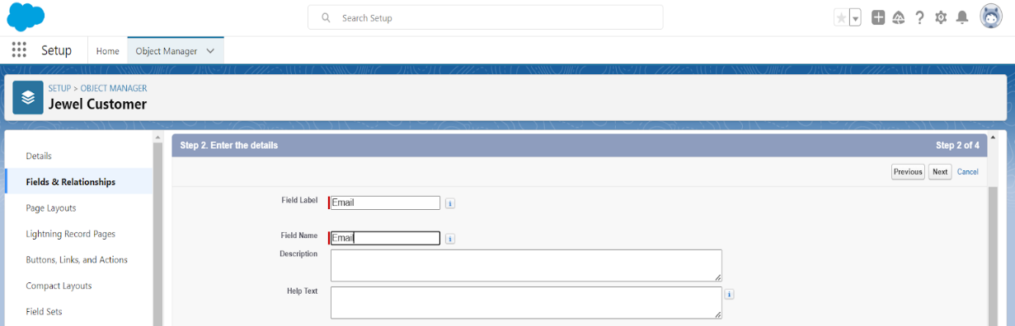
5. Field Name will be auto populated, and click on Next >> Next >> Save.

### 5.6 Creating the number field in Item object

To create fields in an object:

1. Go to setup >> click on Object Manager >> type object name(Item) in quick find bar >> click on the object.
2. Now click on “Fields & Relationships” >> New
3. Select Data type as “Number” and click Next.
4. Given the Field Label as “ Purity” and length as “ 2 ”.  
   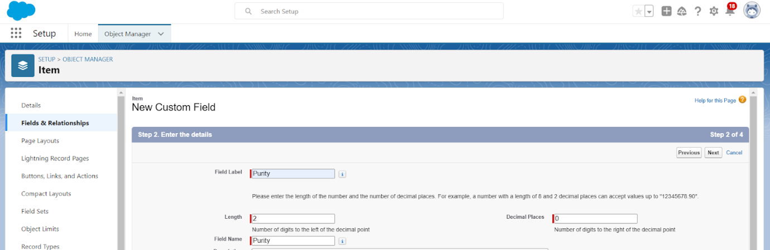
5. Field Name will be auto populated, and click on Next >> Next >> Save.

### 5.7 Creating Picklist Field in Item Object

To create fields in an object:

1. Go to setup >> click on Object Manager >>type object name(Item) in quick find bar >> click on the object.
2. Now click on “Fields & Relationships” >> New.
3. Select Data type as “Picklist” and click Next.
4. Enter Field Label as “Item Type”.
5. In values select “Enter values(Gold,Silver), with each value separated by a new line" and enter values as shown below.

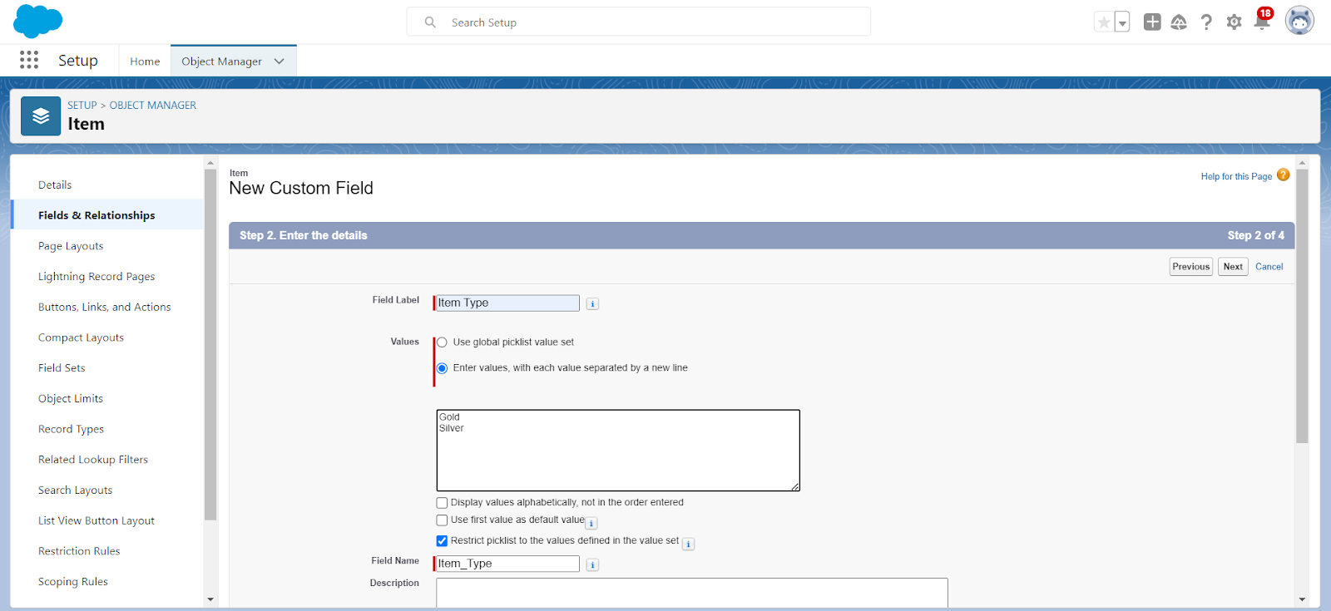

1. Click Next >> Next >> Next >> Save .

### 5.8 Creating Currency Field in Price Object

To create fields in an object:

1. Go to setup >> click on Object Manager >> type object name(Price) in quick find bar >> click on the object.
2. Now click on “Fields & Relationships” >> New.
3. Select Data type as “Currency” and click Next.

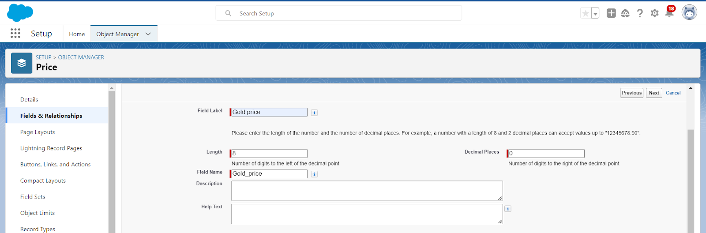

1. Enter Field Label as “Gold Price” and length as “ 8”and decimal 5.Field name will be auto generated.
2. Click Next >> Next >> Next >> Save .

### 5.9 Creating Formula Field(Cross Object) in Item Object

To create fields in an object:

(Note:Create a Lookup Relationship in Item Object to Price Object with Field Name:Prices)

1. Go to setup >> click on Object Manager >> type object name(Item) in quick find bar >> click on the object.

1. Now click on “Fields & Relationships” >> New.
2. Select Data type as “Formula” and click Next.
3. Give Field Label and Field Name as “Gold Price” and select formula return type as “Currency” and click next.

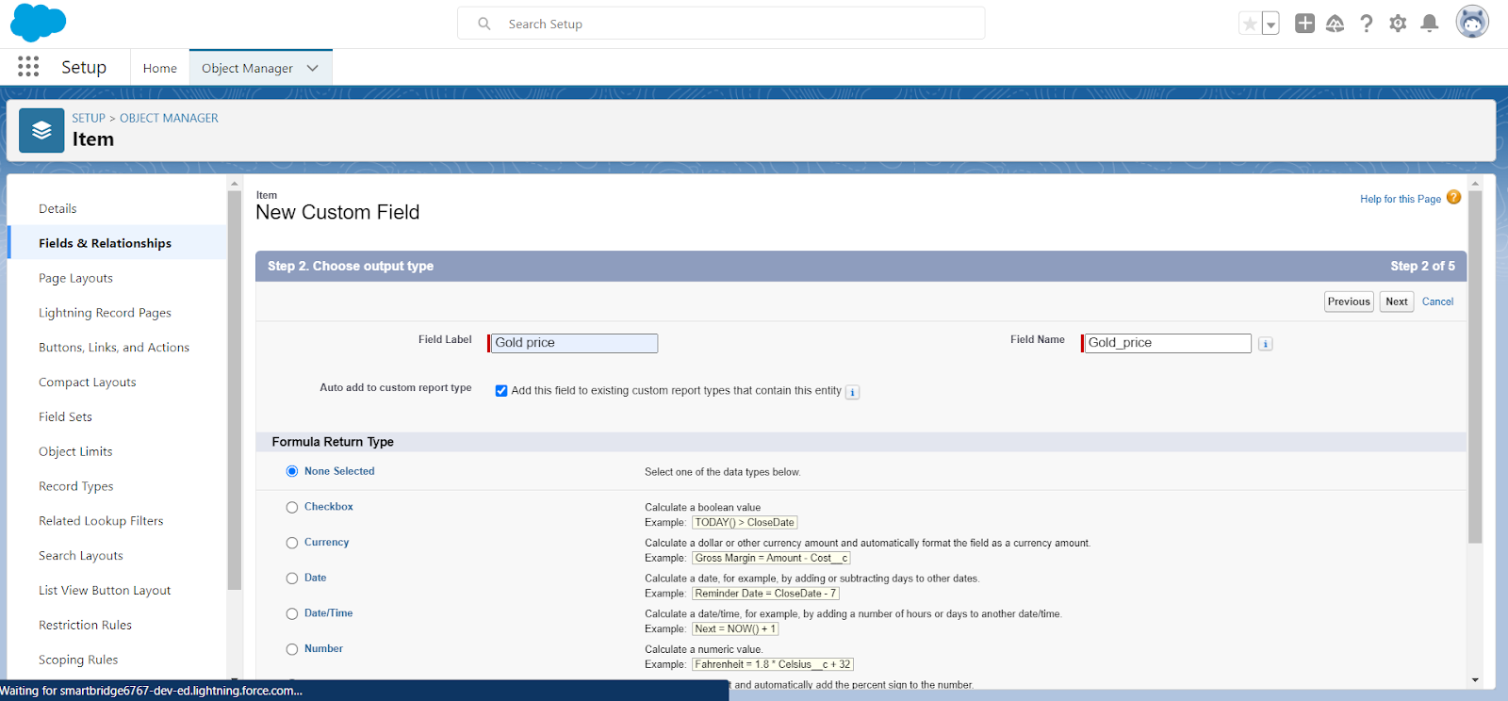

1. Under Advanced Formula write down the formula :Prices__r.Gold_price__c  / 10.

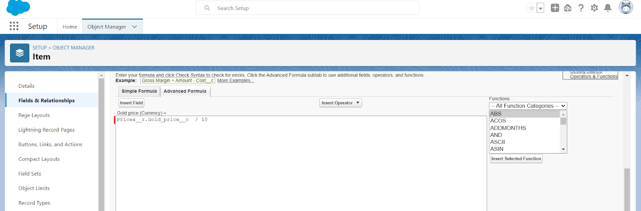

1. click “Check Syntax” and Next >> Next >> Save & New.

### 5.10 Creating Remaining Fields in Objects

### Now create the remaining fields using the data types mentioned.

|  |  |  |
| --- | --- | --- |
| s.no | Object name | Fields |
| 1 | Jewel Customer | |  |  | | --- | --- | | Field Name | Data type | | State | Text(20) | | Street | Text(20) | | Country | Text(18) | | Zip/Postal code | Text(6) | |

|  |  |  |  |  |
| --- | --- | --- | --- | --- |
| 2 | Price | |  |  | | --- | --- | | Silver Price | Currency  (Length=8,Decimal=5) | |

|  |  |  |  |  |  |  |  |  |  |  |  |  |  |  |  |  |  |  |  |  |  |  |  |  |  |  |  |  |  |  |  |  |  |  |  |  |  |  |
| --- | --- | --- | --- | --- | --- | --- | --- | --- | --- | --- | --- | --- | --- | --- | --- | --- | --- | --- | --- | --- | --- | --- | --- | --- | --- | --- | --- | --- | --- | --- | --- | --- | --- | --- | --- | --- | --- | --- |
| 3 | Item | |  |  | | --- | --- | | Field Label:Customer Name | Lookup Relationship with Jewel Customer Object | | Ornament | Text(20) | | Weight | Number  (Length=8,Decimal=5) | | Stone Weight | Number  (Length=5,Decimal=5) | | Percentage | Number  (Length=2,Decimal=0) | | Stone/Other Price | Currency  (Length=8,Decimal=2) | | Expected Days Of Return | Picklist   |  | | --- | | 1-3 Days  4-5 Days  6-7 Days  8-10 Days | | | Priority | Picklist   |  | | --- | | Low  Medium  High  Critical | | | Silver Price | Formula     (Return Type:Number)  (Decimal=3)   |  | | --- | | (Prices__r.Silver_price__c  / 1000) | | | Purity Gold Price | Formula     (Return Type:Currency)            (Decimal=2)   |  | | --- | | ((Prices__r.Gold_price__c *  Purity__c ) / 24) / 10 | | | Total Weight | Formula      (Return Type:Number)  (Decimal=3)   |  | | --- | | (Weight__c  -  Stone_weight__c) | | | Amount | Formula  (Return Type:Currency)  (Decimal=3)   |  | | --- | | IF(ISPICKVAL( Item_Type__c ,"Gold"), Total_weight__c  *   Purity_Gold_price__c  , Total_weight__c  *  Silver_price__c ) | | | KDM | Formula  (Return Type:Currency)  (Decimal=0)   |  | | --- | | (Amount__c    *  Percentage__c  ) / 100 | | | Making Charges | Formula  (Return Type:Currency)  (Decimal=0)   |  | | --- | | IF(ISPICKVAL( Item_Type__c ,"Gold"),  Weight__c   *  300 ,  Weight__c  *  10 ) | | |

|  |  |  |  |  |  |
| --- | --- | --- | --- | --- | --- |
| 4 | Customer Order | |  |  |  | | --- | --- | --- | | Order Status | Picklist   |  | | --- | | Started  Not Started  On Hold  Completed  Not Completed | | |

|  |  |  |  |  |  |  |  |  |  |  |  |  |  |  |  |  |  |  |  |  |  |  |  |  |  |  |  |  |  |  |  |
| --- | --- | --- | --- | --- | --- | --- | --- | --- | --- | --- | --- | --- | --- | --- | --- | --- | --- | --- | --- | --- | --- | --- | --- | --- | --- | --- | --- | --- | --- | --- | --- |
| 5 | Billing | |  |  | | --- | --- | | Field Label:Item | Lookup Relationship                with Item Object | | Ornament | Formula      (Return Type:Text)     |  | | --- | | Item__r.Ornament__c | | | Stone weight | Formula      (Return Type:Number)              (Decimal=2)     |  | | --- | | Item__r.Stone_weight__c | | | Weight | Formula         Return Type:Number              (Decimal=2)   |  | | --- | | Item__r.Total_weight__c | | | Amount | Formula      (Return Type:Currency)  (Decimal=2)   |  | | --- | | Item__r.Amount__c | | | Gold/Silver Price | Formula      (Return Type:Currency)  (Decimal=2)   |  | | --- | | IF(ISPICKVAL(  Item__r.Item_Type__c  ,"Gold"),  Item__r.Gold_price__c  ,  Item__r.Silver_price__c  ) | | | KDM Charge | Formula      (Return Type:Currency)  (Decimal=0)   |  | | --- | | Item__r.KDM__c | | | Making Charges | Formula      (Return Type:Currency)  (Decimal=2)   |  | | --- | | Item__r.Making_Charges__c | | | Stones/other price | Formula      (Return Type:Currency)  (Decimal=2)   |  | | --- | | Item__r.Stone_other_price__c | | | Total Amount | Formula      (Return Type:Currency)  (Decimal=0)   |  | | --- | | Amount__c   + KDM_Charge__c  +  Stones_other_price__c  +  Making_Charges__c | | |

### 5.11 Schema Builder

Schema Builder is a powerful tool within Salesforce that allows you to visualise, explore, and design the relationships between objects in your Salesforce organisation. It provides a graphical representation of the data model, making it easier to understand the structure and connections between different objects.

Creating Schema Builder

1. Go to setup >> click on Object Manager >> Schema Builder.
2. Select objects >> Enter Objects as “Jewel Customer,Item,Customer Order, Price, Billing objects” in quick box and select them.

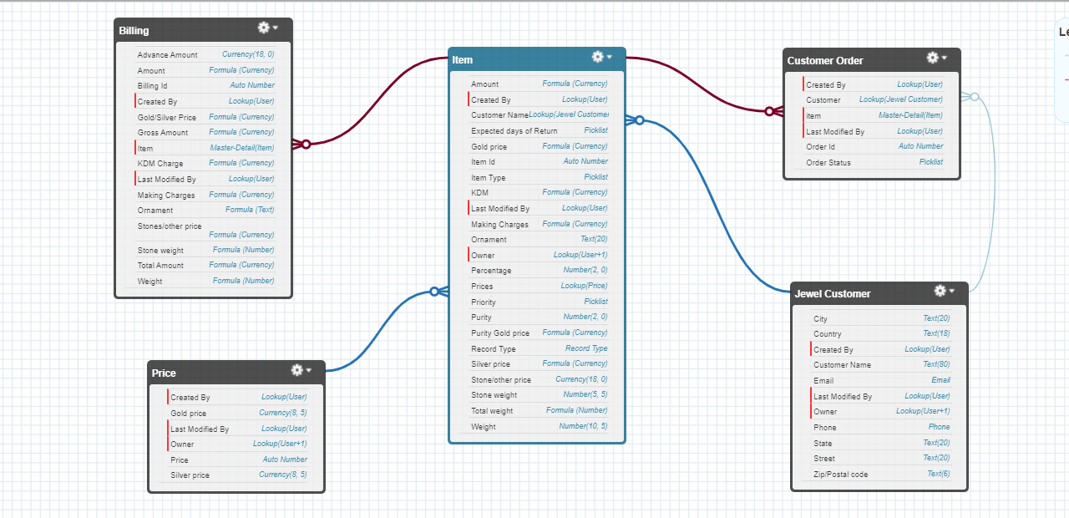

### 5.12 Creating the Field Dependencies

Use case:

Field Dependencies  are used to create relationships between fields within an object. They allow you to control the visibility and availability of fields based on the values selected in other fields.

1. Go to setup >> click on Object Manager >> type object name(Item) in quick find bar >>click on the object.
2. Click on Fields & Relationships and click on the Priority field.
3. Search for Field Dependencies and click on New.

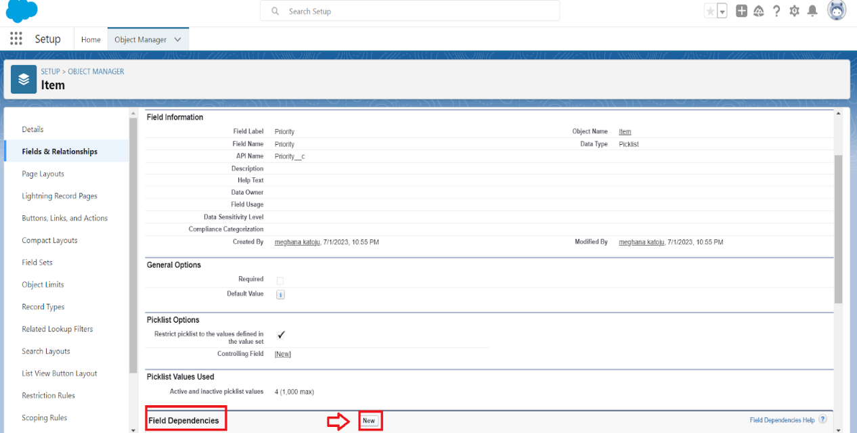

1. Select Controlling Field as “Priority” and Depending field as “Expected Days of Return”>>Continue.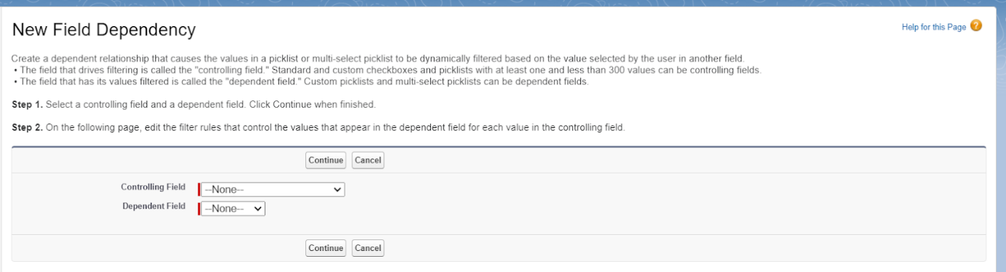
2. Select the “Expected Days of Return” values of related Priority values and Click on Include Values >> Save.

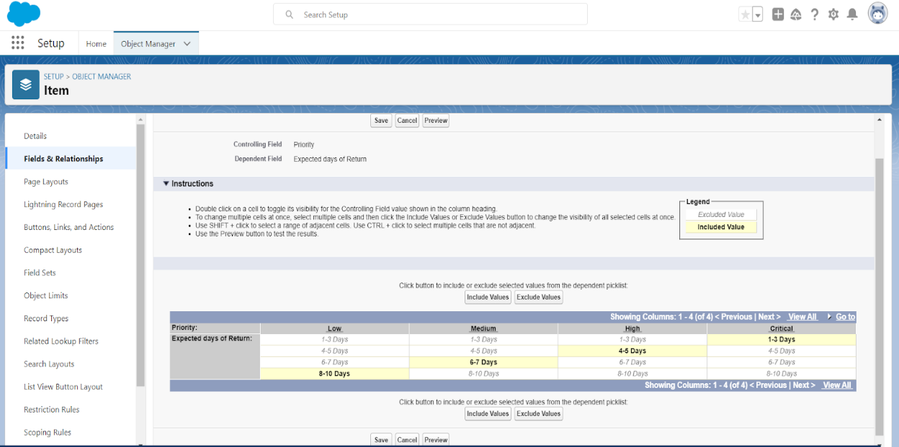

### 5.13 Creating the validation rule

### Creating the validation rule for Postal Code field in Jewel Customer object

Note :check whether the fields mentioned in the formula field are created or not , if not go to activity 10 and create those fields mentioned in Jewel Customer object.

1. Go to setup >> click on Object Manager >> type object name(Jewel Customer) in quick find bar >> click on the object.
2. Click on the validation rule >> click New

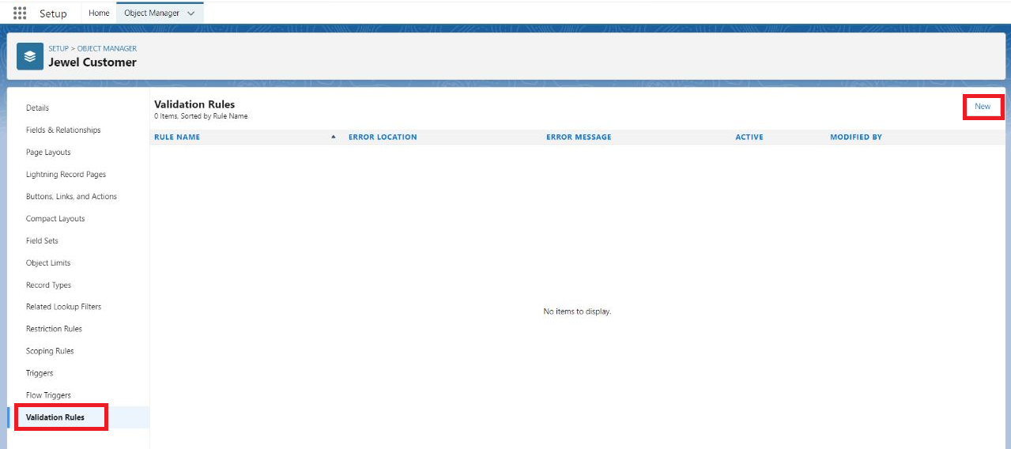

1. Enter the Rule name as “Postal Code “.
2. Insert the Error Condition Formula as : -

AND(

  OR(

    LEN( Zip_Postal_code__c ) <> 6,

    NOT(REGEX(Zip_Postal_code__c, "^[0-9]{6}$"))

  ),

  NOT(ISBLANK(Zip_Postal_code__c))

)

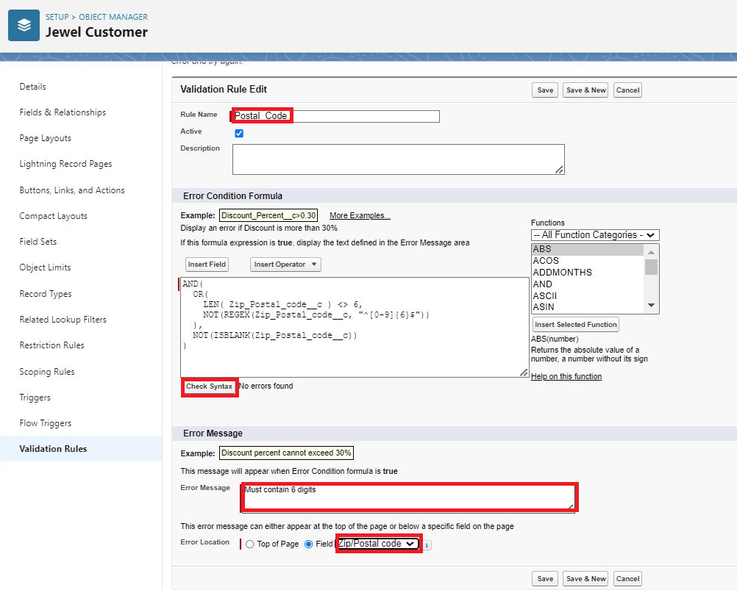

1. Enter the Error Message as “Must contain 6 digits”, select the Error location as Field and select the field as “Zip/Postal code”, and click Save.

NOTE:

 Create One more Validation rule for Jewel Customer object.

1. Enter Rule name as “ValidationRule For JewelCustomerObject “.
2. Insert the Error Condition Formula as : -

    OR( ISBLANK( City__c ) , ISBLANK( Country__c ),ISBLANK( Phone__c ),ISBLANK( State__c ),ISBLANK(     Street__c ) )

1. Enter the Error Message as “Please fill Required fields”, select the Error location as Top of Page and click Save.

Create Validation rule for Item object.

1. Enter Rule name as “ValidationRule For Item“.
2. Insert the Error Condition Formula as : -OR( ISBLANK(  Amount__c  ) , ISBLANK(  Customer_Name__c  ) ,ISBLANK( Gold_price__c ),ISBLANK( KDM__c ),ISBLANK( Ornament__c ),ISBLANK( Percentage__c ),ISBLANK( Making_Charges__c ),ISBLANK( Prices__c ),ISBLANK( Stone_weight__c ),ISBLANK( Silver_price__c ),ISBLANK( Stone_other_price__c ),ISBLANK( Stone_weight__c ),ISBLANK( Weight__c ))
3. Enter the Error Message as “Please fill Required fields”, select the Error location as Top of Page and click Save.

### TASK:6 Profiles

### 6.1 Gold Smith Profile

To create a new profile:

1. Go to setup >> type profiles in quick find box >> click on profiles >> clone the desired profile (System Administrator) >> enter profile name (Gold Smith) >> Save.

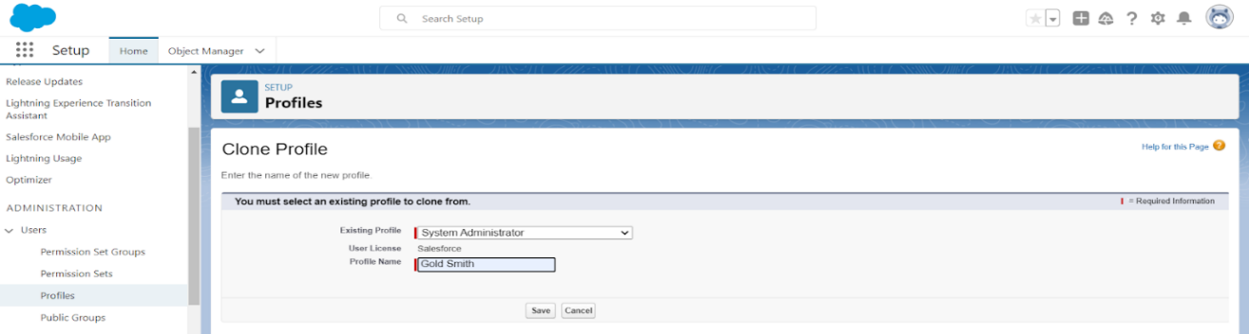

1. While still on the profile page, then click Edit.
2. Scroll down to Custom Object Permissions and Give access permissions for Jewel Customer,Item,Customer Order,Prices,Billings .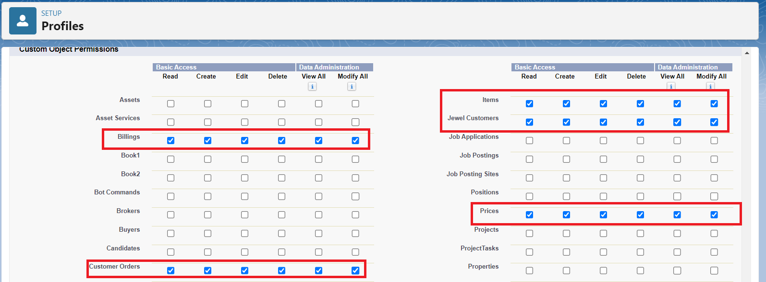
3. Scroll down and Click on Save.

### 6.2 Worker Profile

1. Go to setup >> type profiles in quick find box >> click on profiles >> clone the desired profile (Salesforce Platform User) >> enter profile name as worker profile>> Save.
2. While still on the profile page, then click Edit.
3. Scroll down to Custom Object Permissions and Give access permissions for Items,Price and Customer Order objects.
4. Scroll down and Click on Save.

### TASK:7 Roles

### 7.1 Creating Gold Smith Role

1. From setup >> Go to quick find >> Search for Roles >> click on set up roles.

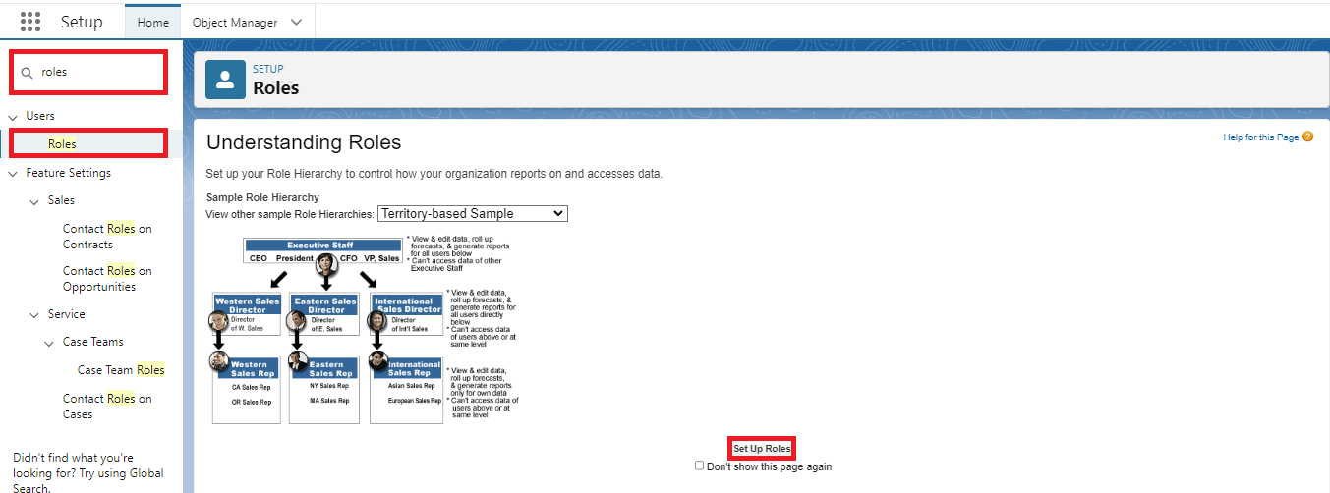

1. Click on Expand All and click on add role under whom this role works.

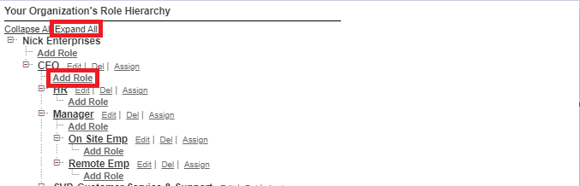

1. Give Label as “Gold Smith” and Role name gets auto populated. Check to whom this role (Gold Smith) reports. Then click on Save.

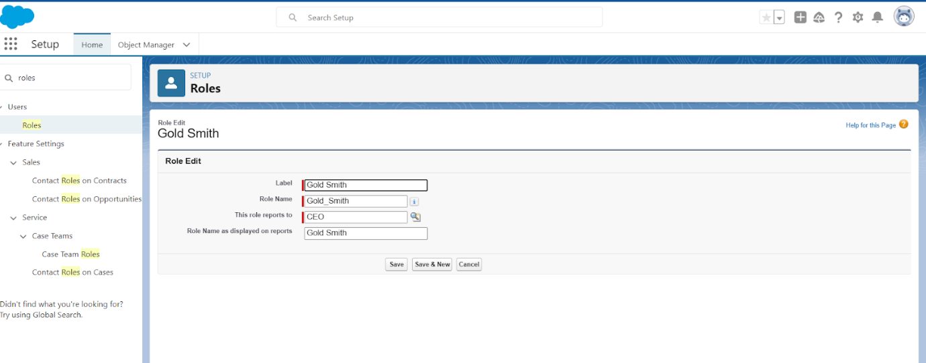

Note:

Create one more role as Worker  which reports to Gold Smith.

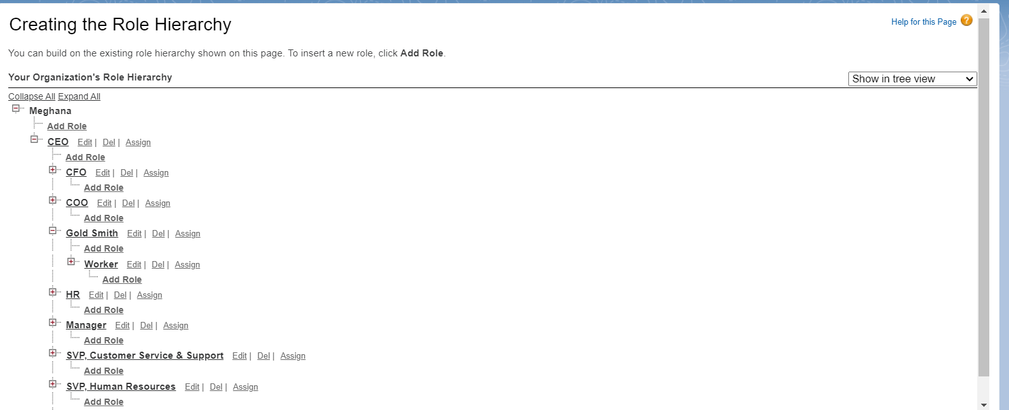

### TASK:8 Users

### 8.1 Create User

1. Go to setup >> type users in quick find box >> select users >> click New user.
2. Fill in the fields
3. First Name: Niklaus
4. Last Name: Mikaelson
5. Alias: Give a Alias Name
6. Email id: Give your Personal Email id
7. Username: Username should be in this form: text@text.text
8. Nick Name: Give a Nickname
9. Role: Gold Smith
10. User licence: Salesforce
11. Profiles: Gold Smith

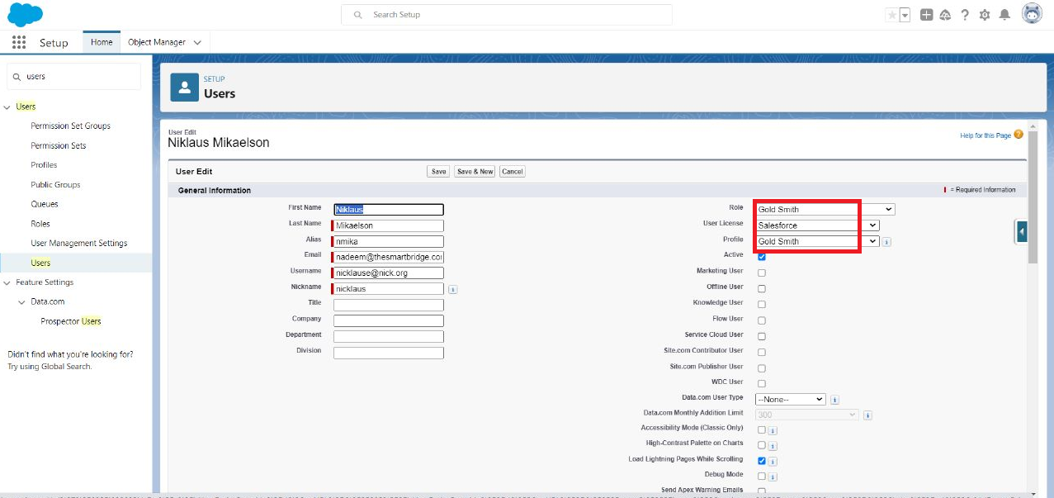

1. Save.

### 8.2 Create User

1. Go to setup >> type users in quick find box >> select users >> click New user.
2. Fill in the fields

* First Name:Kol
* Last Name: Mikaelson
* Alias: Give a Alias Name
* Email id: Give your Personal Email id
* Username: Username should be in this form: text@text.text
* Nick Name: Give a Nickname
* Role: Worker
* User licence: Salesforce Platform
* Profiles: Worker

1. Save.

Note:

Create two more users as mentioned in activity 2 using the same profile.

### TASK: 9 Page layouts

### 9.1 To Create a Gold Page layout

1. Go to Setup >> Click on Object Manager >> Search for the object (Item) >> From drop down click on Edit.
2. Click on Page layout >> Click on New.

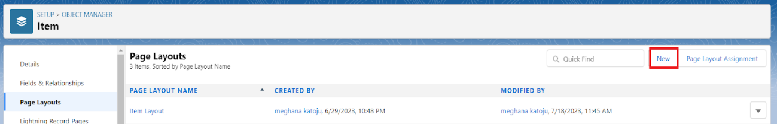

1. Give Page layout Name as “Page Layout for Gold” and click on Save.

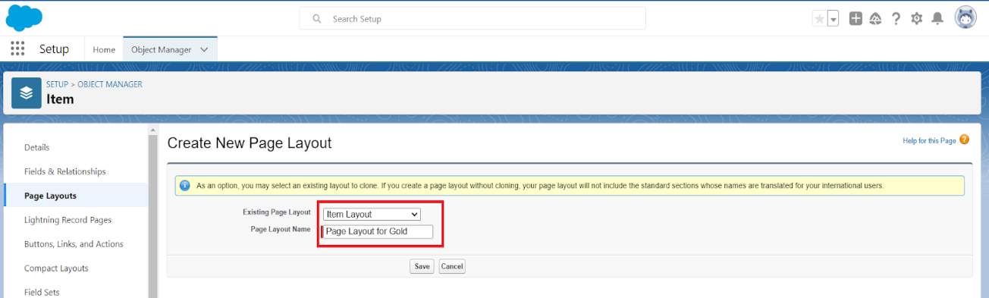

1. Arrange the field as shown in the Information Section ,remove fields which are related to Silver and click Ok.

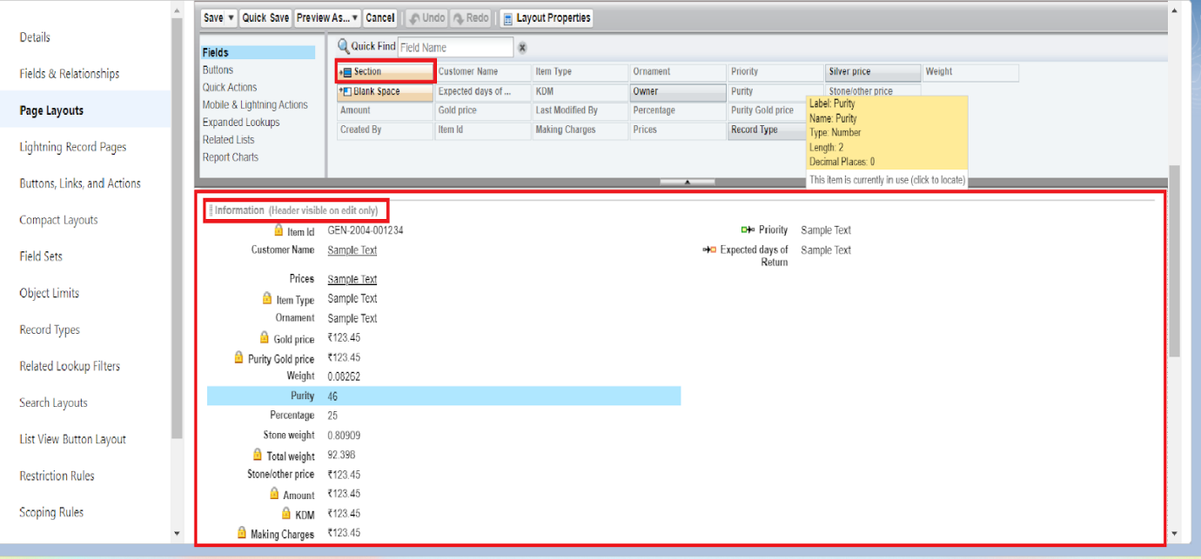

1. Click Save.
2. Make sure your page layout looks like the picture above.

### 9.2 To Create a Silver Page layout

1. Go to Setup >> Click on Object Manager >> Search for the object (Item) >> From drop down click on Edit.
2. Click on Page layout >> Click on New.
3. Give Page layout Name as “Page Layout for Silver” and click on Save.
4. Arrange the field as shown in the Information Section ,remove fields which are related to Gold  and click Ok.

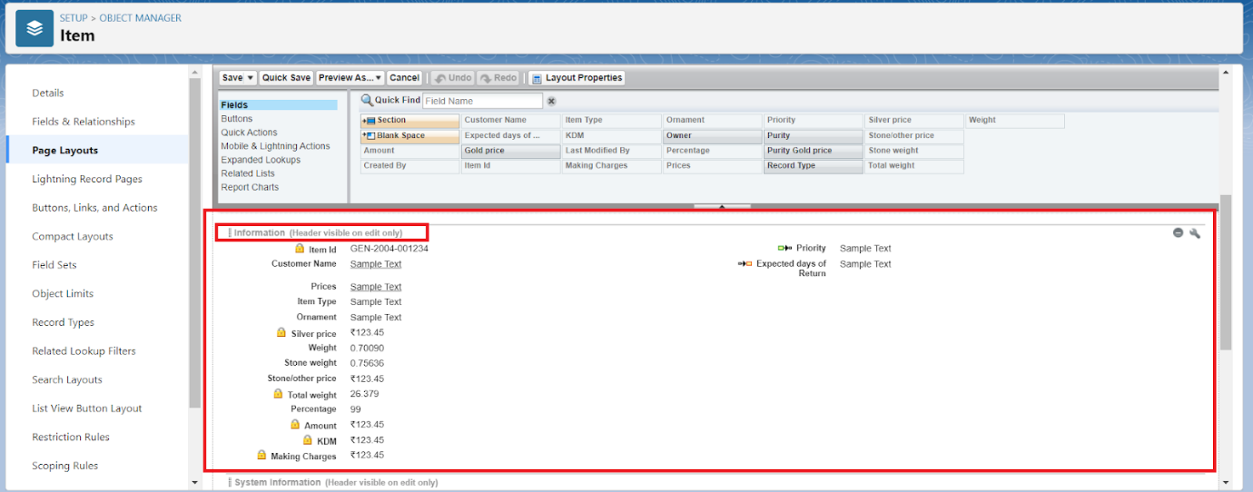

### TASK:10 Record Types

### 10.1To create a Record Type

1. Go to setup >> click on Object Manager >> type object name(Item) in quick find bar >> click on the object.
2. Click on the Record Types >> click New.

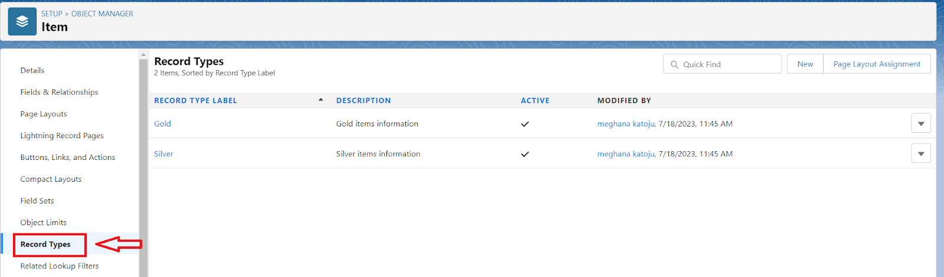

1. Select Existing Record as “Master”,Record type Label as “Gold”,Description as “Gold items information”.

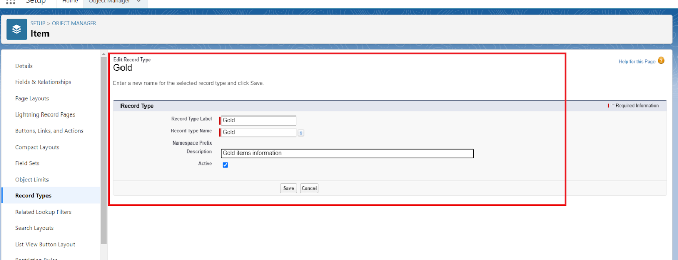

1. Uncheck for “Make Available”.  
   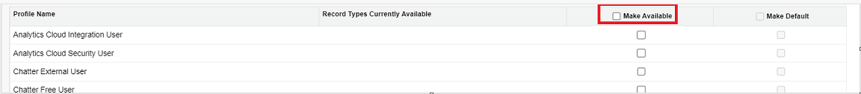
2. Scroll  down and check for the Gold Smith,Worker & System Administrator profile and click on Next.
3. Select “Apply a different layout for each profile”, and change page layout to “Page Layout for Gold“for Gold Smith,Worker and System Administrator >> save & new.

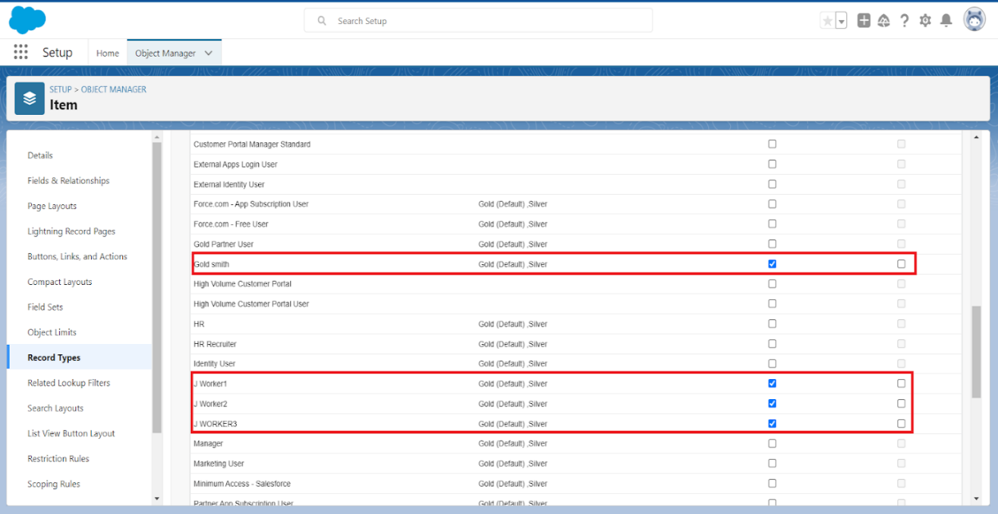

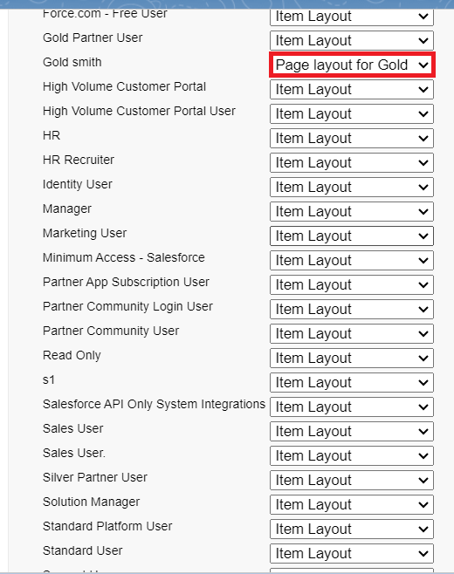

Note:Create another Record Type with name “Silver” following the steps from Activity1(Use page layout for Silver).

### TASK:11 Permission sets

### Creating permission set

A permission set is a collection of settings and permissions that give users access to various toolsand functions. Permission sets extend users' functional access without changing their profiles.Users can have only one profile but, depending on the Salesforce edition, they can have multiplepermission sets.

1. Go to setup >> type “permission sets” in quick search >> select permission sets >> New.

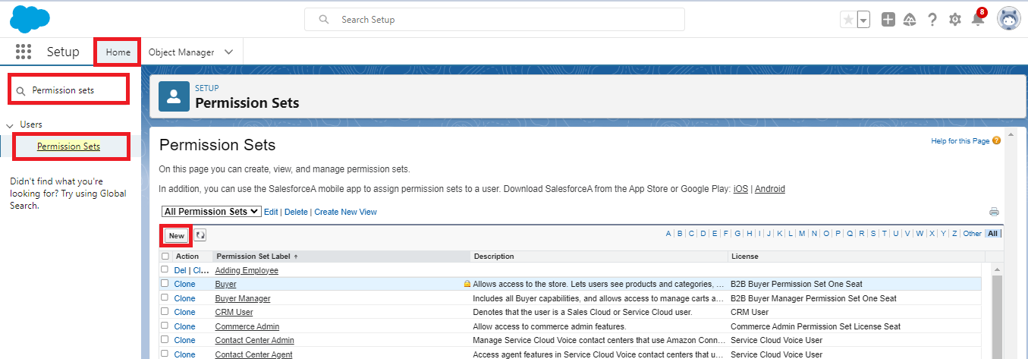

1. Enter the label name as “Per to Worker”, API will be auto populated >> save.

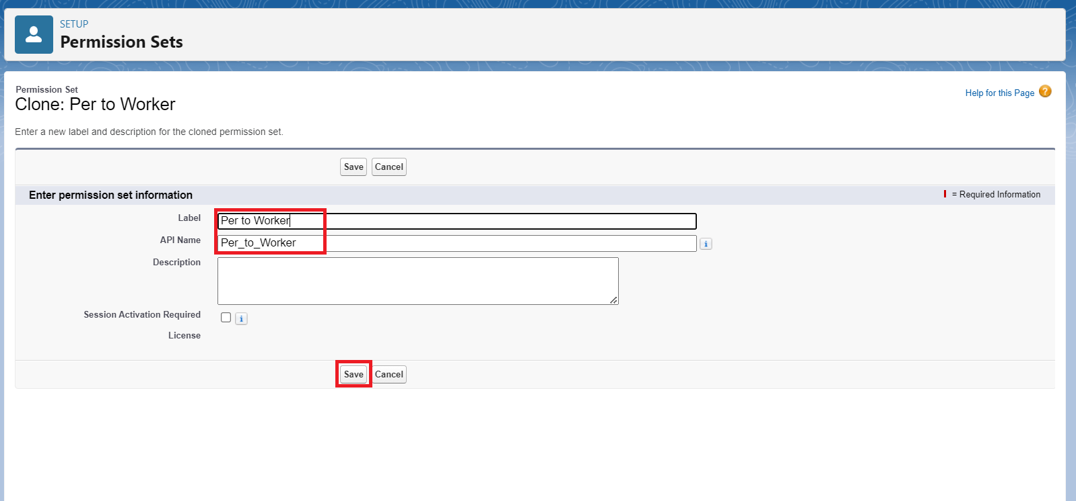

1. Under Apps Select object settings.

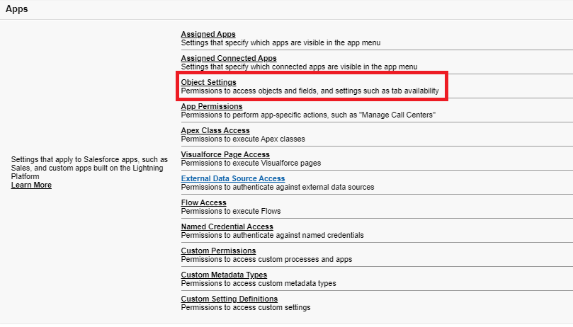

1. Click on Items object  >> click on Edit >> under Item:Record Type Assignments,enable Gold,Silver  >> Object permission check for read ,edit and create.

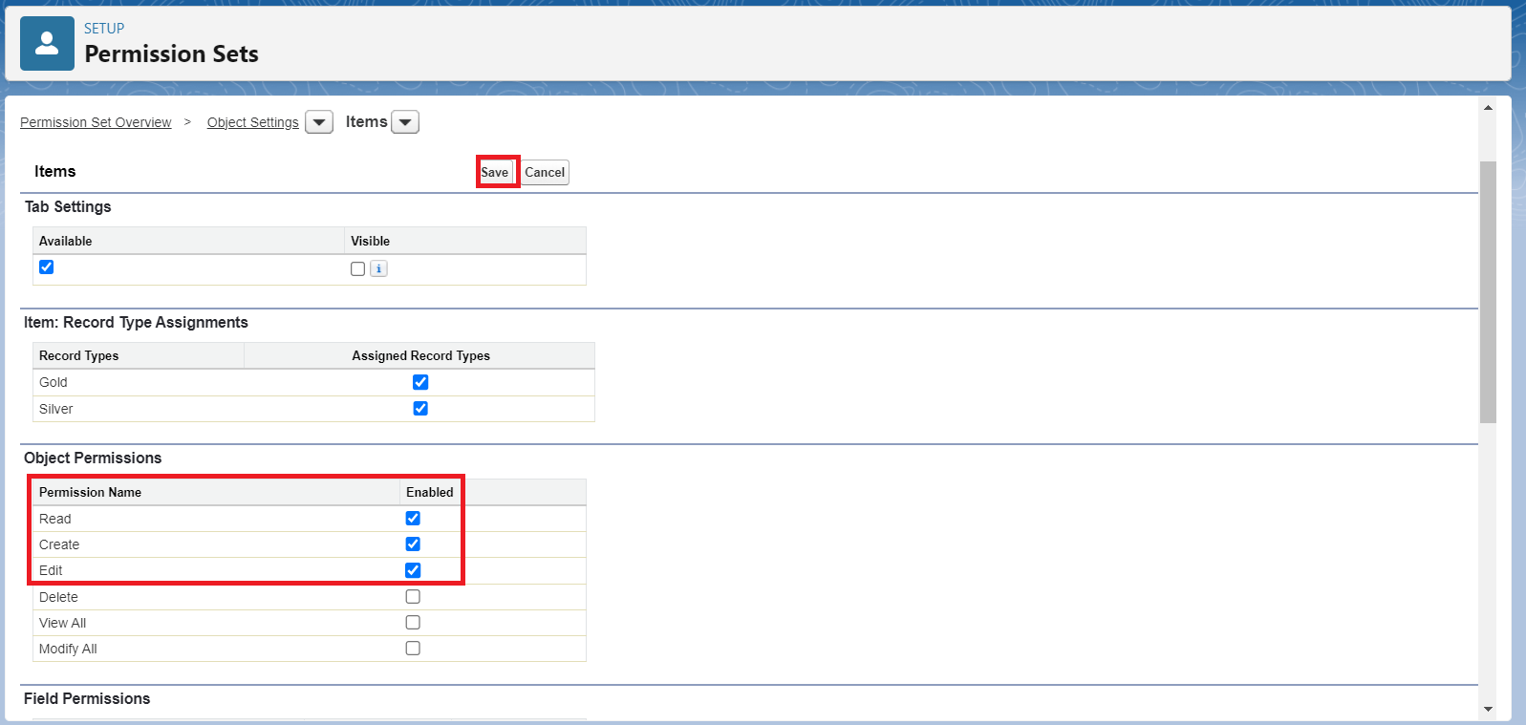

1. Click on Save.
2. After saving the permission click on the Manage assignment
3. Now click on the Add Assignment.



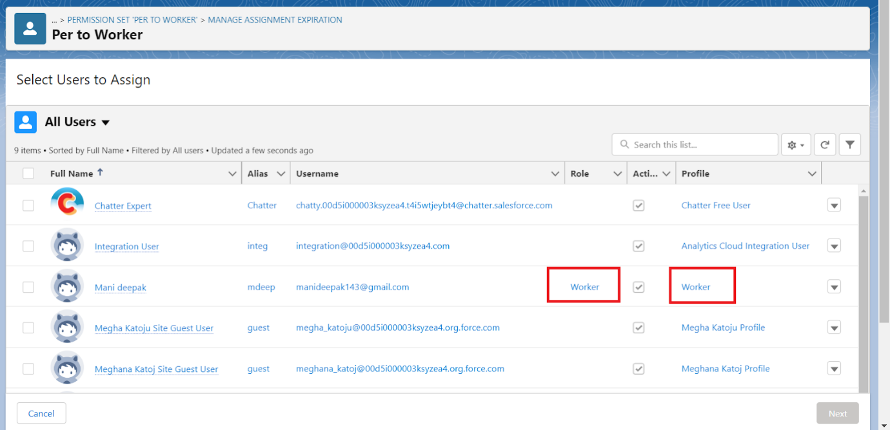

1. Now select the users which you have created in user milestone, using  Worker profile and click on Next >> Assign >> Done.

### TASK:12 User Adoption

### 12.1 Create a Record (Jewel Customer)

1. Click on App Launcher on the left side of the screen.
2. Search Jewelry Inventory System & click on it.
3. 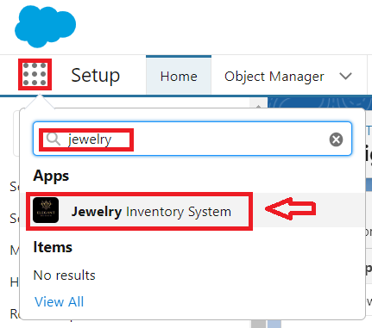
4. Click on Drop Down and Click on the Jewel Customer tab.
5. Click New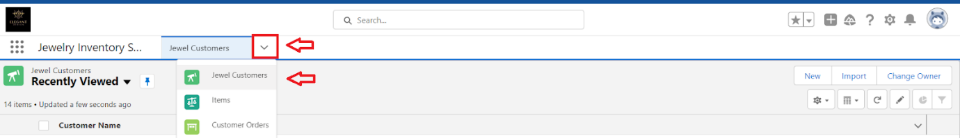
6. Fill the details and click on save.

### 12.2 View a Record(Jewel Customer)

1. Click on App Launcher on the left side of the screen.
2. Search Jewelry Inventory System & click on it.
3. Click on the Jewel Customer Tab.
4. Click on any record name. you can see the details of the Jewel Customer.

### 12.3 Delete a Record(Jewel Customer)

1. Click on App Launcher on the left side of the screen.
2. Search Jewelry Inventory System & click on it.
3. Click on the Jewel Customer Tab.
4. Click on Arrow at right hand side on that Particular record.
5. Click delete.

Note: Create at least 10 records for each of the objects: Jewel Customer, Price, Item, Customer Order and Billing.

### TASK:13 Reports

### 13.1 Create Report

1. Go to the app >> click on the reports tab.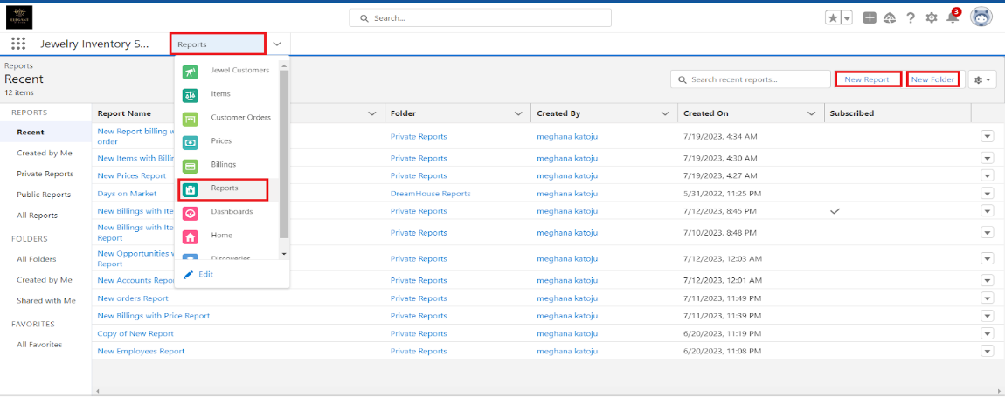
2. Click New Report.
3. Select report type from category or from report type panel or from search panel ? click on start report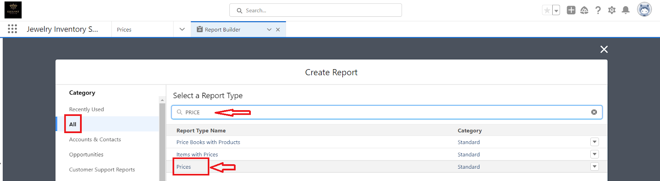
4. Customise your report.
5. Add fields from the left pane as shown below

.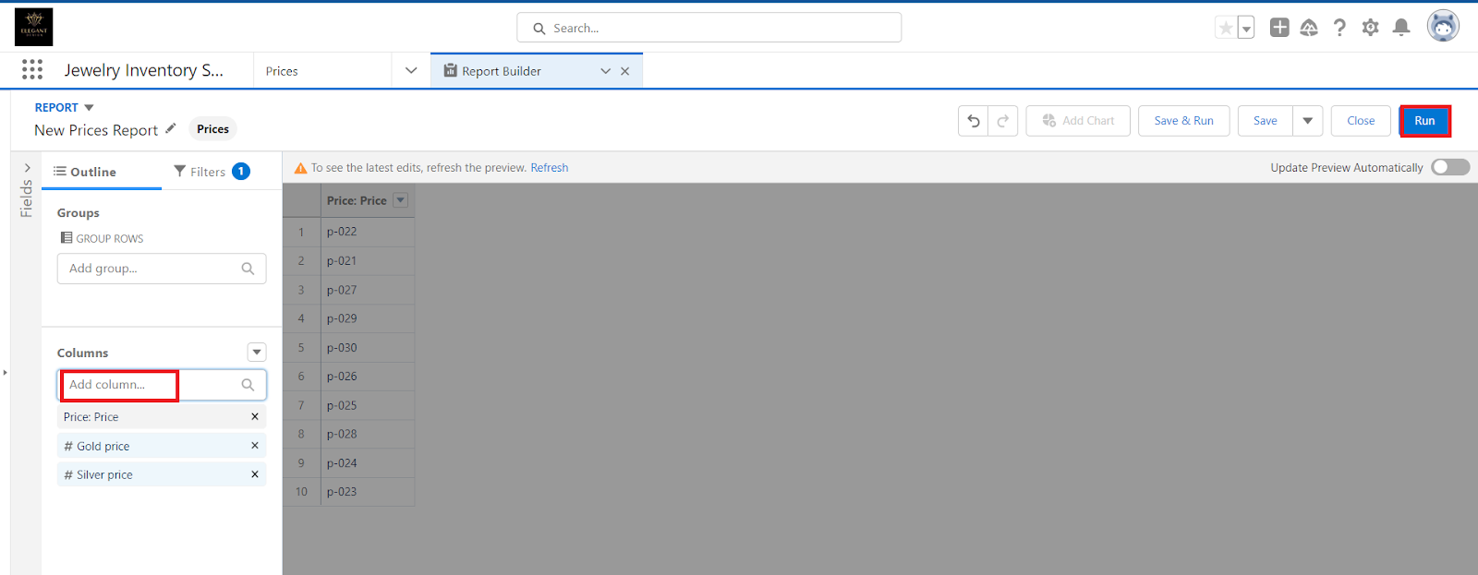

1. Save or run it.

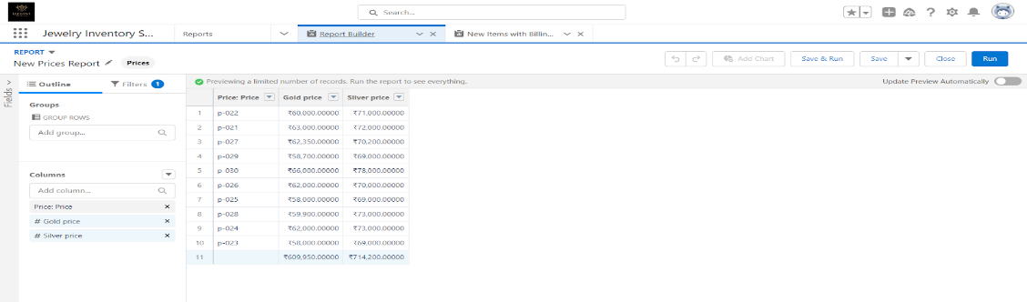

Note:Reports may get varied from the above pictures as the data might be different.

### 13.2 Creating Report

1. Create a report with report type: “Item with Billings”.
2. Create a report with report type: “Billings with item and Customer order”.

### TASK:14 Dashboards

### 14.1 Creating Dashboards

Go to the app>>click on the Dashboards tabs.

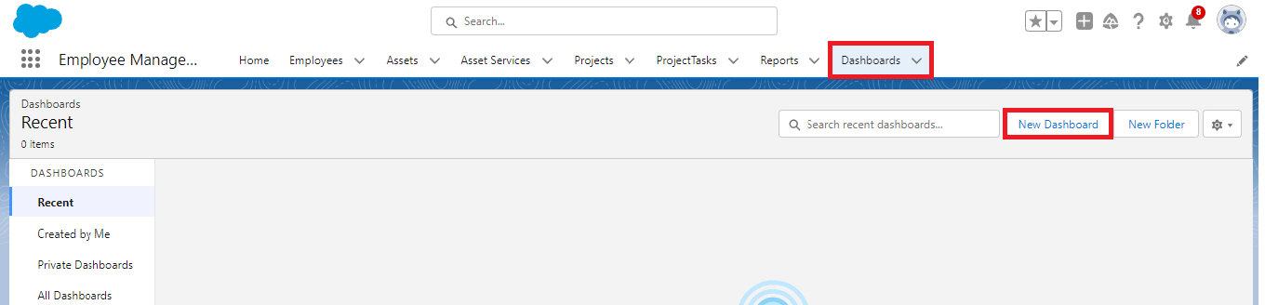

1. Give a Name and click on Create.

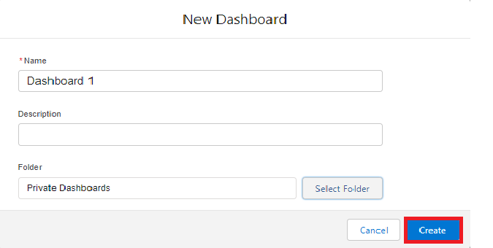

1. Select add component.



1. Select a Report and click on select.

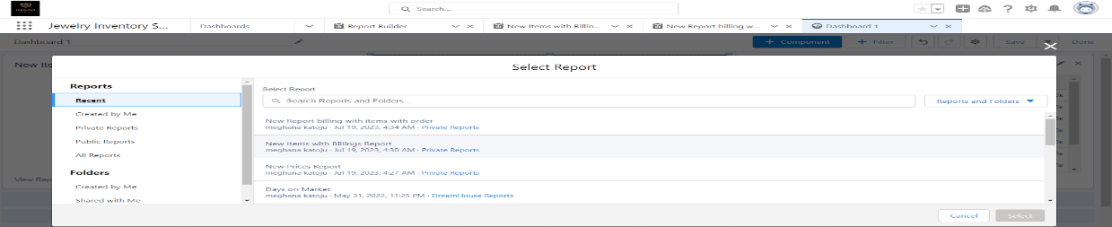

1. Click Add then click on Save and then click on Done.

Note: Create another Dashboard as we discussed in activity 1.

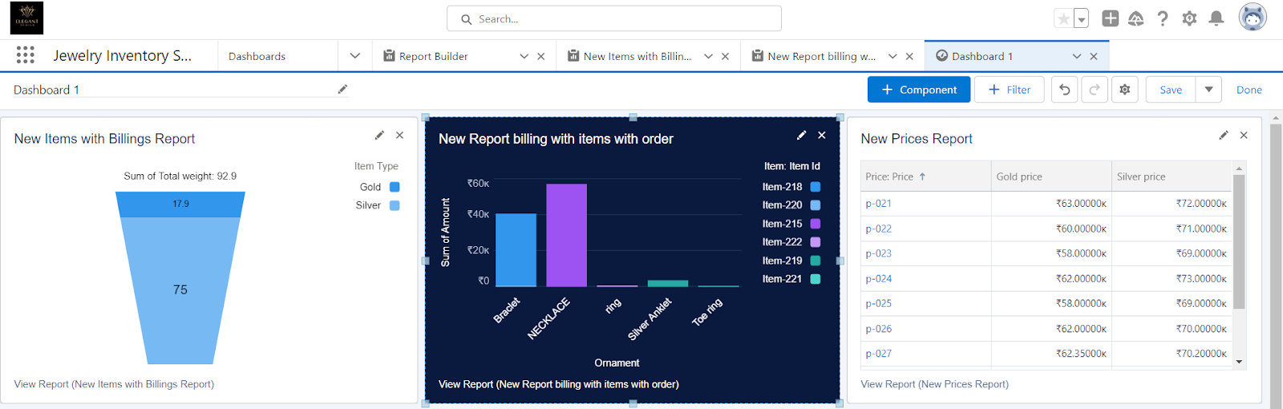

### TASK:15 FLOW

### 15.1 Create a Flow

1. Go to setup >> type Flow in quick find box >> Click on the Flow and Select the New Flow.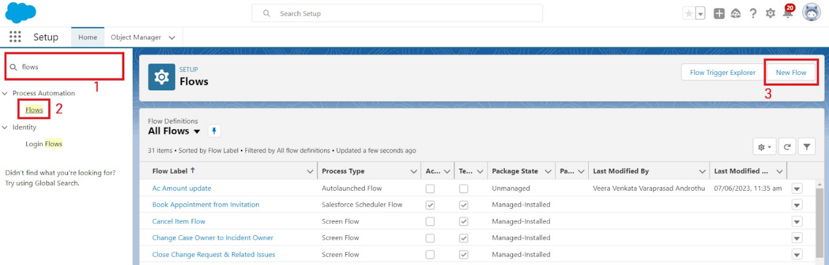
2. Select the Record-triggered flow and Click on Create.

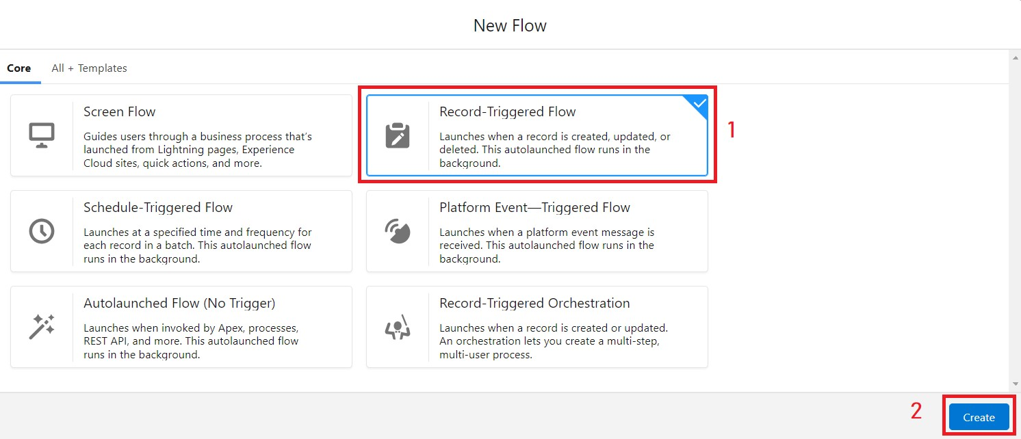

1. Select the Object as a “Billing” in the Drop down list.
2. Select the Trigger Flow when: “A record is Created or Updated”.
3. Select the Optimize the flow for: “Actions and Related Records” and Click on Done.
4. Now change the mode form Auto-layout to free-form.
5. Now select the manger option in the toolbox, click New resource. 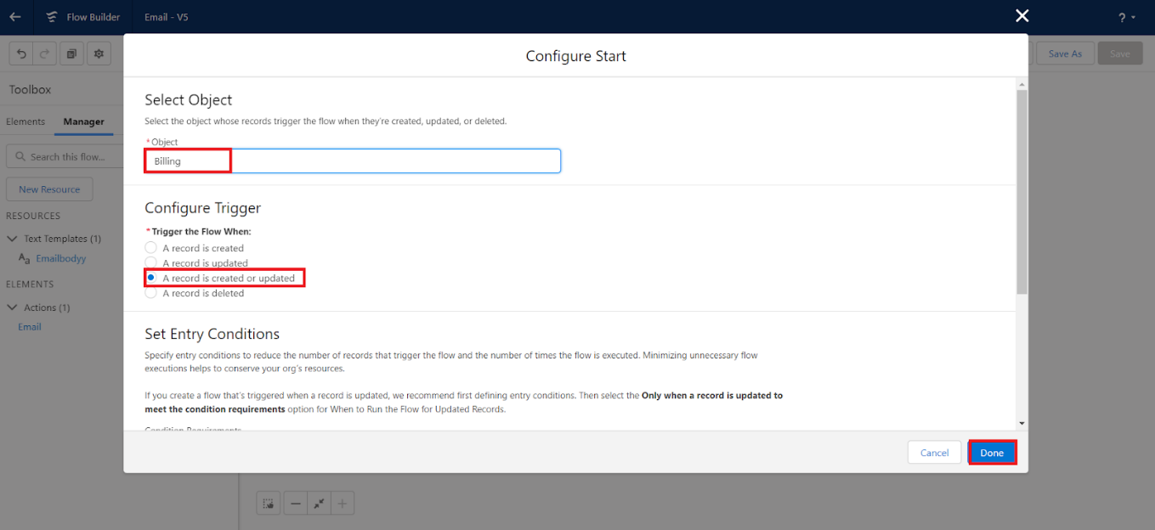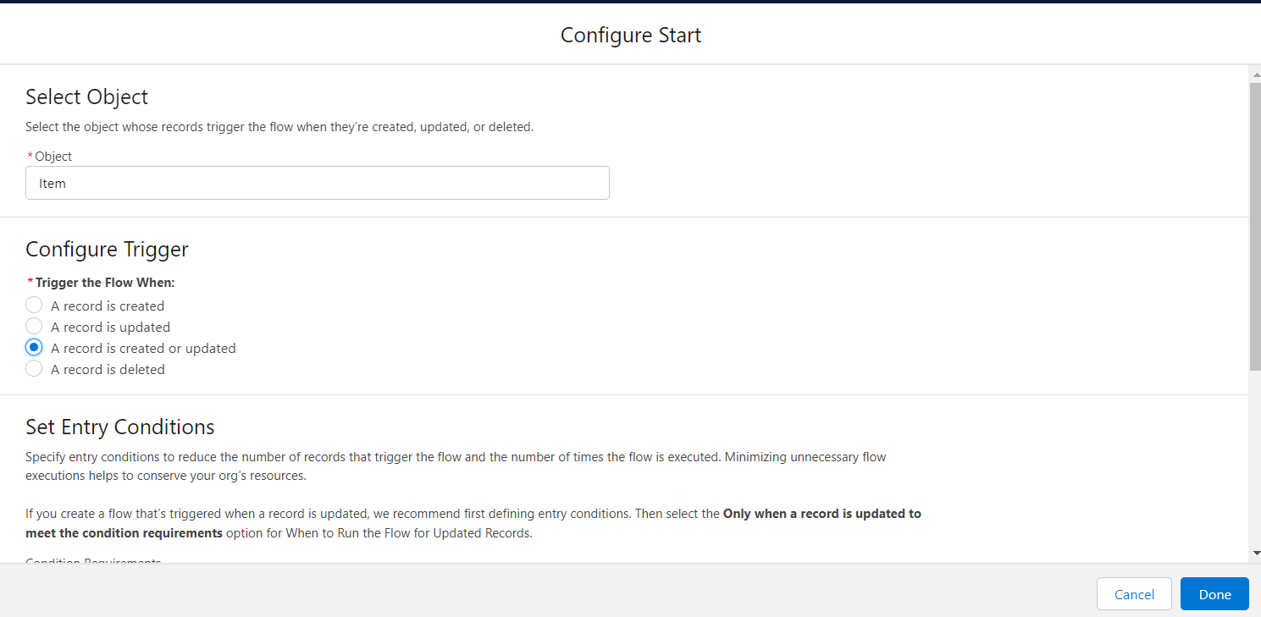
6. Select the resource type as text templat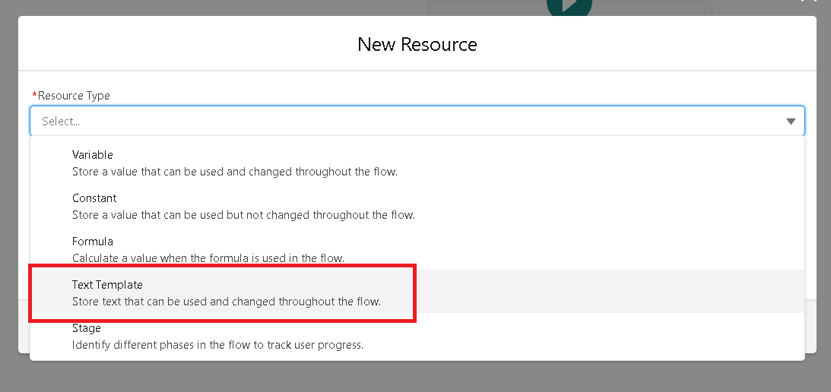e.
7. Enter the API name as “ Email body”.

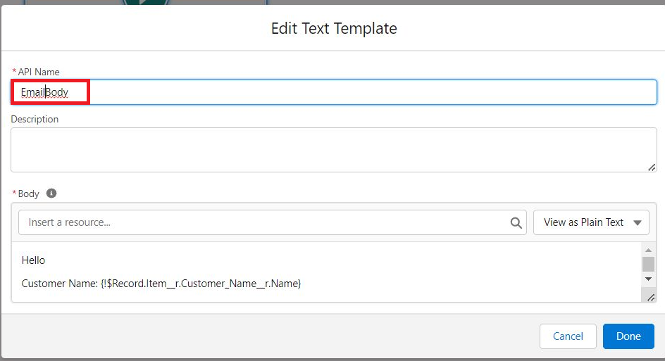

1. Change the view as Rich Text>>View to Plain Text.
2. In the body field  paste the syntax that is given below.

Hello

Customer Name: {!$Record.Item__r.Customer_Name__r.Name}

Here are the details for the item you purchased with Jewelry Inventory System

Item Type: {!$Record.Item__r.Item_Type__c}

Ornament: {!$Record.Ornament__c}

Weight: {!$Record.Weight__c}grams

Amount: {!$Record.Amount__c}

1. Click done.
2. Now click on elements, and drag the action element into the preview pane.
3. Their action bar will be opened in that search for “ send email ” and click on it.
4. Give the label name as “ notice”
5. API name will be auto populated.
6. Enable the body in set input values for the selected action.
7. Select the text template that was created.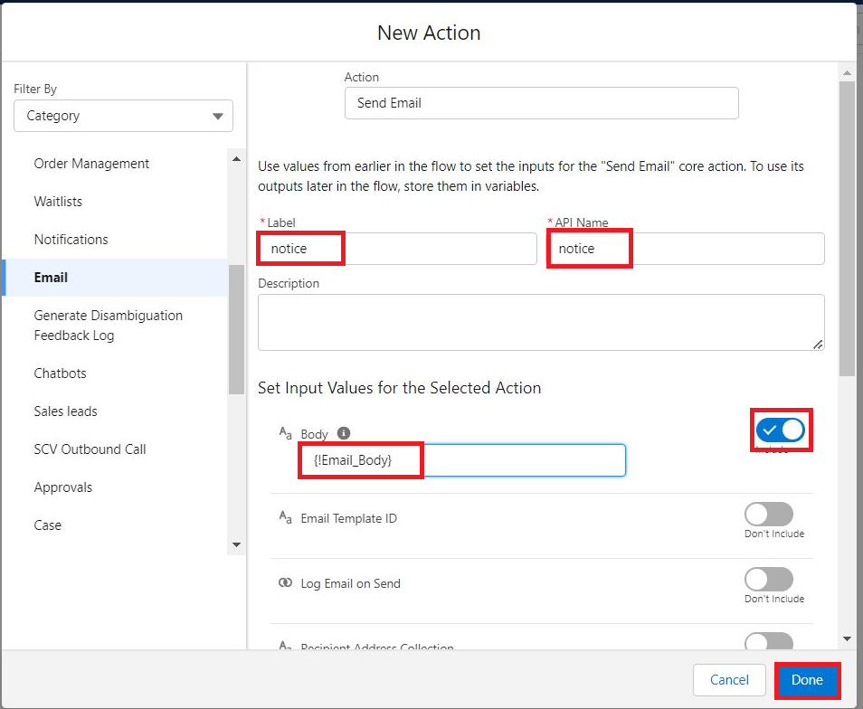
8. Include Recipient Address list, select the email form the record.

({!$Record.Item_r.Customer_Namer.Email_c})

1. Include the subject as “Welcome to Jewelry Inventory System ”.Click done.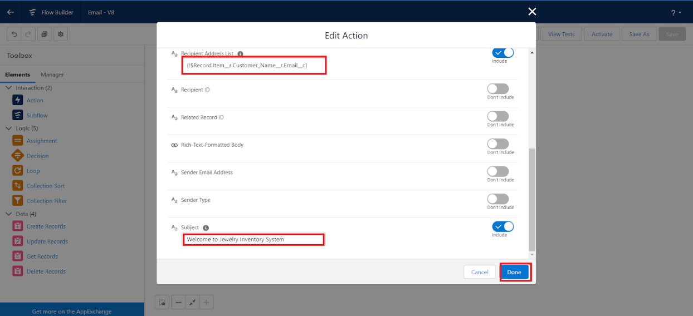
2. Now drag the path from the start to the action element.
3. Click on save. Given the Flow label  , Flow Api name will be auto populated.

.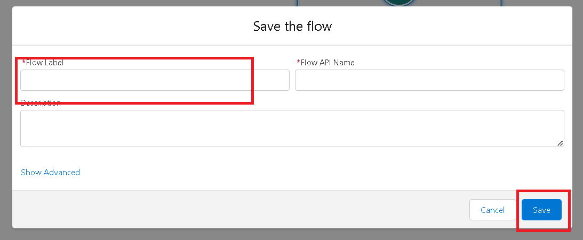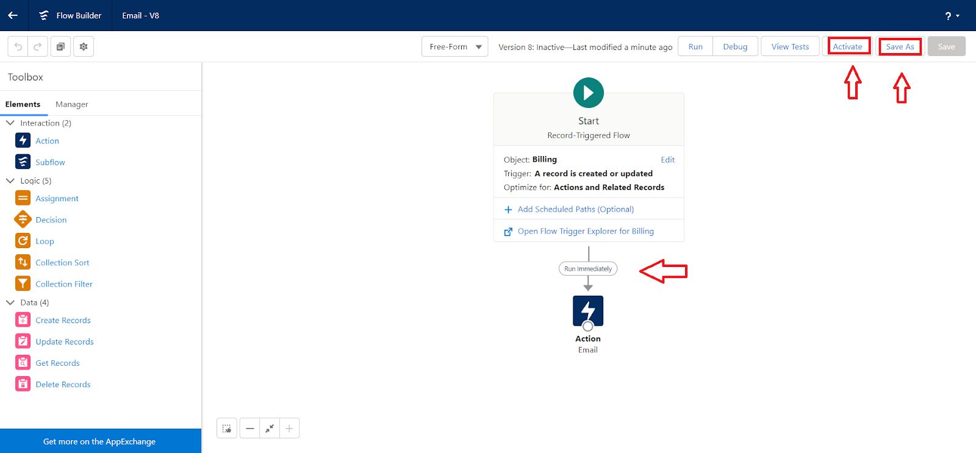

1. And click save, and click on activate.

**THANK YOU**